Module Description

The module is a child of Calidad Module.

Calidad

Incidencias

Dashboard

Lista

Nueva

The ticket model data is inside AppsMain.edmx in the incident diagram.

Remember this module is a Site and role dependent so you have to inckude in the main app a variable call userSite and a collection called userrols to develop this solution.

Set userSite = 1 and create a record with this id in Site table. All tickets should have a siteid .

Set userrols with two elements for example, salesmanager and factoryemployee. Remenebr that some views and tasks in this module are allowed only to certain roles.

With this variables you have to check sometimes the role to performs some actions or show some data; during this explanation you will see “rol dependent” so there you have to check if user have the role if has not the view element has not to be shown or the action cannot be performed.

Also remember that the ticket element should have the siteID.

**SCREENS**

Dashboard screen is now a copy of crm dashboard (the already migrated one) waiting until the DW data model is finish and the incidencias module is completely finished to define this content

The Nueva Screen. This is a screen to create a new Ticket. (Remember there is another screen that should be created in HTML5 that has the same functionality (explained later)

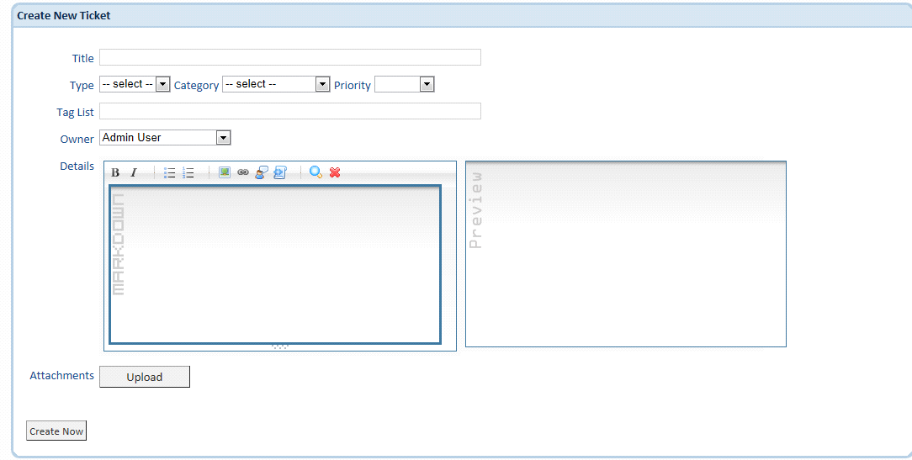

with this differences of internal or external use:

external (html5): hasn't type, category, priority, owner. Has contact email, name, surname, company, phone number.

internal: has area (business area of company), ¿is emergency?, contact information: Company, company contact.

We will explain the ticket creation process and data.

Title is the main title of the incident this field is always available.

Type the type is only one selection field from a list of possibilities, this possibilities are defined in the configuration module. Depends of the role user also can create a new type. Is an autocomplete box (capital letter independent). If there is no user logged then this field is not presented (external page)

Category has same functionality as Type

Details is a rich text box to introduce the description of the incident (could have also pictures on it?) check telerik controls (should be on Silverlight and in asp.net mvc controls) if yes we could change the details field to a Blob type perhaps. **(this is a plus)**.

Taglist this is colletion of tags that can be indexed for future search same functionality as type but with a taglist look and fell.

Owner this comes from employee table (remember that AppsMain employee table and CRM employee table is going to be merged in only one at AppsMain), an only one selection can be made a ticket cannot be created if this field is not filled. If the ticket is created from the external HTML5 page then this field is filled with a standard employeeId. Also this field is not presented to the external user.

The attachment button opens the right panel on the last one (download). Here is a Prism region. This view is used to present a list of documents and upload/download operations.From here you can see the list of attachments of the ticket or make and upload of an attachment to the ticket. (this fills the ticketattachment table).

**Lista screen** == Take inspiration from opportunities->list crm example.

The lista screen presents the tickets in a list (please keep the look and feel and think about how is the best way to present data.

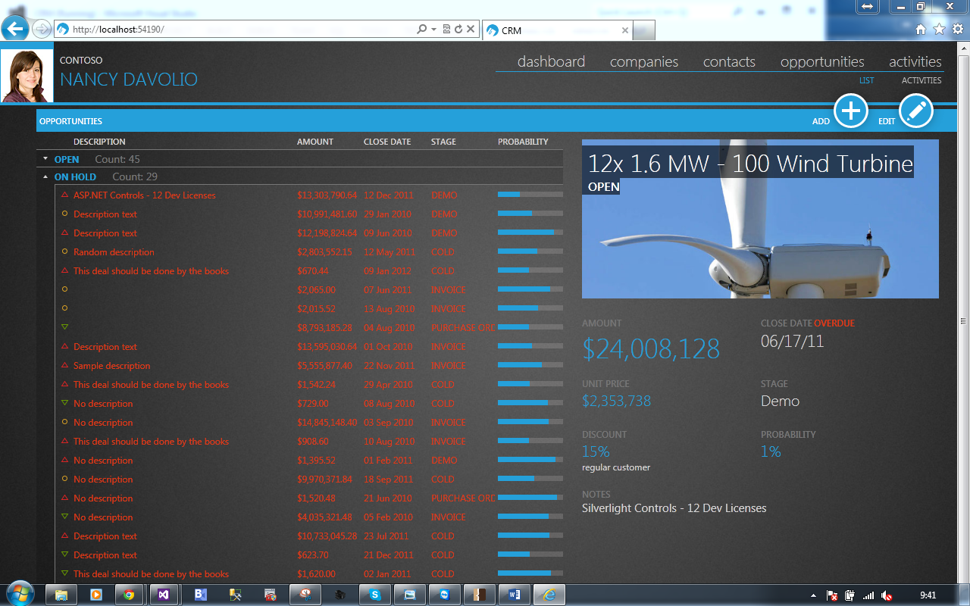

In the left the ticket list, instead of (shown in the order

Description -> title

Stage -> type

Amount -> category

Close date -> createdDate

Probability -> Importance; you should show the bar according to the next formula:

Group by -> currentstatus.

If the user is (this is going to came from claims engine) from a role then you should show also the assignedto in the list.

Currentstatus elements:

Currentstatus is going to be an element of a table maintained inside the configuration module, it’s entity is TicketStatus This elements have the following status that can not be removed or modified by administrators, others can be created/removed/edited by administrators.

The elements that can not modified are (name field)

Abierto (Open)

Cerrado (Closed)

In the right side of the screen you should sho the information of the ticket the photograp is the first of the attachments of type jpg, bpm,etc (image)